TOPIC FOR TUESDAY, JULY 11, 2023:
Meyda Lighting Creating Trellises for Wynn Hospital Lobby

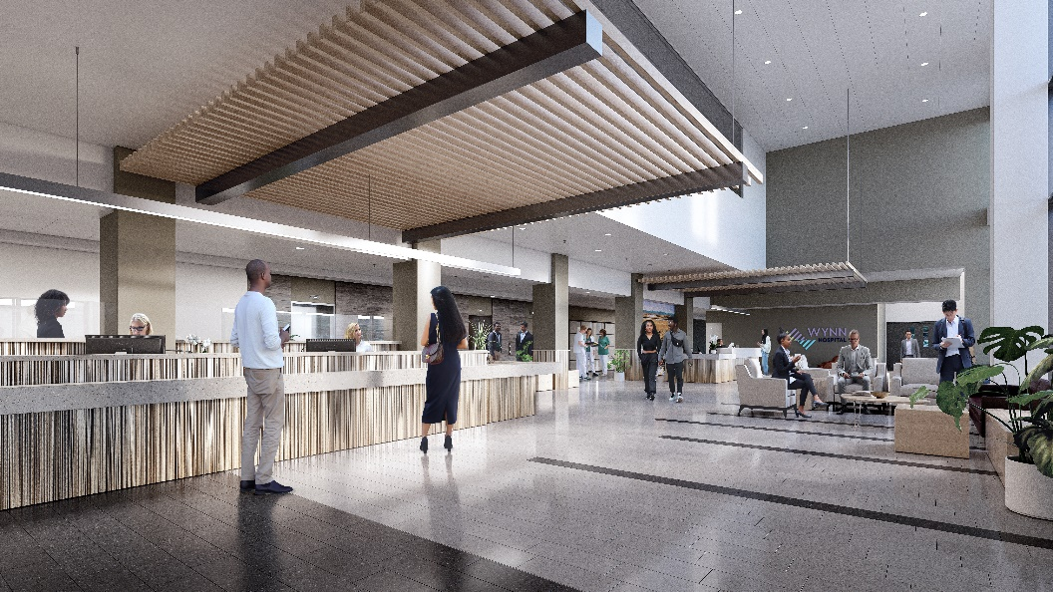
Meyda Lighting out of Yorkville was selected to design, build and install two custom decorative trellises for the Wynn Hospital Lobby (pictured to the right).

Meyda Lighting is a family run business, providing custom lighting throughout the country. One of their most well-known pieces is the massive chandelier hanging in downtown Utica’s Stanley Theater. The chandelier is 35 feet wide, 11 feet tall, weighs over 3 tons, and was created using advanced technology and artisanship.

The trellises in the Wynn Hospital Lobby will be made entirely from powder coated aluminum and will be supported from the second and third floors by cable/rod.

Last week, we were able to stop in the Meyda headquarters and manufacturing facility to check out the work they’ll be doing on the trellises. You can find the video on our YouTube page or below!

