TOPIC FOR TUESDAY, MAY 10, 2022:
Can you tell me about the elevators in the new Wynn Hospital?

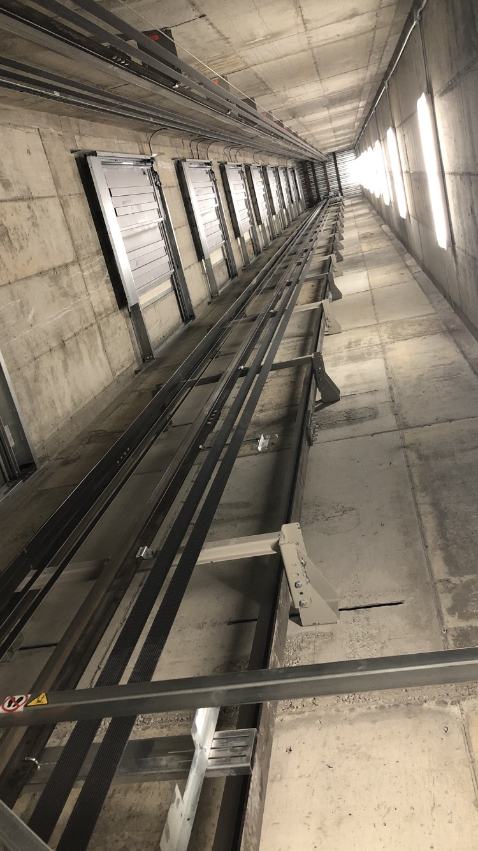
The Wynn Hospital has a total of 13 elevators with separate elevators for visitors, patients and staff. This was an intentional design for a few reasons: greater patient privacy when being transferred between units, improved wayfinding with the visitor elevators connecting areas in a convenient way and a better overall experience as the separate elevators for staff allow them to perform duties such as trash removal and food delivery without sharing an elevator with patients or visitors.

Additionally, international building codes indicate that in buildings with an occupied floor more than 120 feet above the lowest level of fire department vehicle access, no fewer than two fire service access elevators (FSAE) must be in place. Therefore, the Wynn Hospital has two FSAEs which allow firemen and first responders to quickly access different floors throughout the building as well as evacuate occupants in the event of an emergency. There are certain design criteria that must be met for this type of elevator such as lighting at each level (see photo) and a dedicated status panel in the Lobby.

